**Haier Double Deep Fridge**

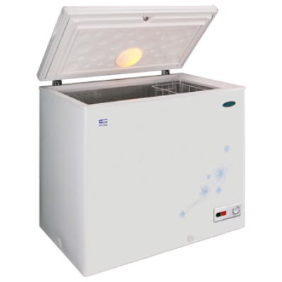

**Key Features  
  
 Total capacity: 604 liters  
 7 segment electronic control  
 Door open warning tone for fridge and freezer section  
 Separate digital electronic temperature control for fridge and freezer  
 section; Display control for temperature, water filter and key on the door  
 Illuminated water and ice / crushed ice dispenser  
 noFrost technology prevents icing and frosting so you never have to defrost  
 Price per Unit: $1050/-**

**CORPORATE OFFICE**

    1300 E. Control Tower Rd.  
    Suite 216 Block L3  
    Englewood CO 80112  
 Phone: 720.974.7878  
    Toll Free: 1.877.929.7878  
    Email: [info@choicescreening.com](mailto:info@choicescreening.com)